Review Activity 2

1. Describe the photo using there is/ there are

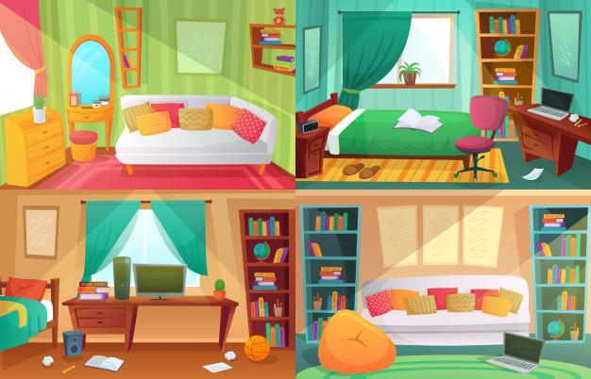

1. There are cushions on the couch;
2. There is a book above the bed;
3. There is a basketball on the floor;
4. There is a Bookshelf in the background.
5. Complete the sentences:

a -___There is___ a cat on my bed.

b-__There are____ two oranges in the box.

c-__There are____ many fruits in the fruit bowl.

d-_There are_____ seven cars in the garage.

e -__There are____ ten books under the table.

f-__There is____ an apple in the fridge.

1. __There is____ a magazine on that shelf.

h - __There is____an alam clock in the bag.

I - _There are_____some dogs on the street.

1. Answer the questions



- Are there 5 People? How many people are there?

No, in the Picture there are 8 people.

- Are there chairs? How many chairs are there?

I see 4 chairs.

*- Is there a Woman wearing Orange clothes?*

Yes,there is.

*- Is there a waiter?*

*Yes, it seems so.*

*- How many lights are there?*

*I see 5 lights.*

- How many tables are there?

I see 4 tables.

4) Coloque o verbo entre parênteses no **Present Continuous**  
  
    a) The Children _playing__________ in the garden (play).  
    b) She ____driving__________ fast today (drive).  
    c) They _____not talking_________ each other today (not talk).  
    d) Be quiet please. The baby __sleeping__________ (sleep).  
    e) At the moment my wife _feeding_________ the dogs and I_watering______ the plants (feed/water).  
    f) Why _you reading_______ the letter again? Because I _checking_______ for spelling mistakes (you read/check).  
    g) The sky ___geting_________ dark. You'd better take an umbrella (get).  
    h) John ___not studing_________ at the momet. He _reading__________ a comic book (not study/read)  
    i) Where is Carla? She __siting___________ in the living room. What _she doing_______? She _watching_______ television (sit/she do/ watch)  
    j) What a nice dress you _wearing__________ today (wear)

1. Describe what is happening:



She is talking on the phone.



The childrens are having fun.



She’s watching TV.



She’s feeding the man.